Nama : Nayla Dwi Ramadhani

Nim : 09010182327002

Kelas : MI 3A

Matkul : Pratikum Jaringan Komputer

**PRATIKUM JARINGAN KOMPUTER**

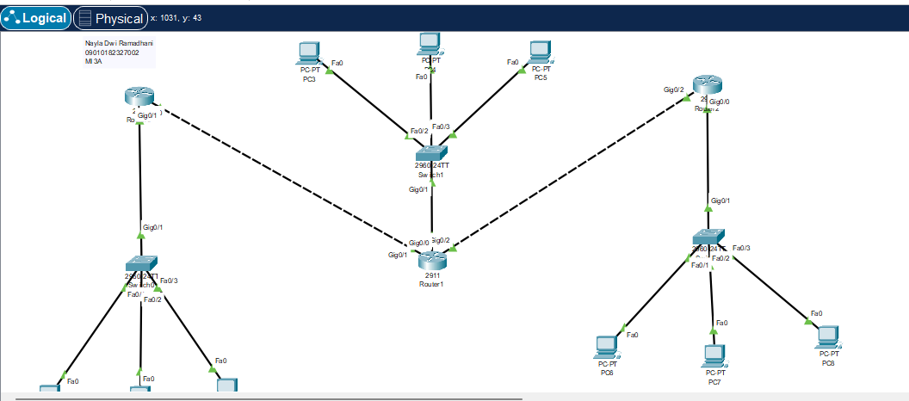

**Router 1**

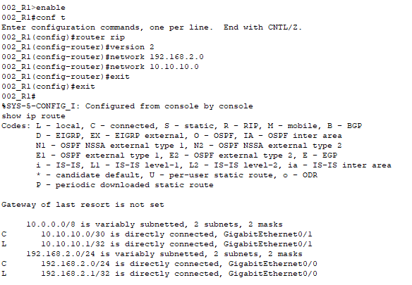

**Router 2**

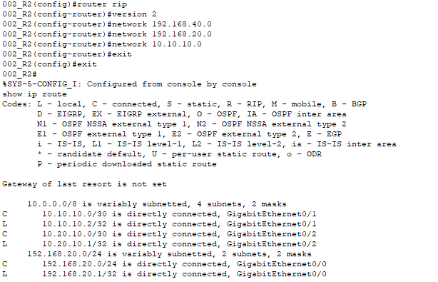

**Router 3**

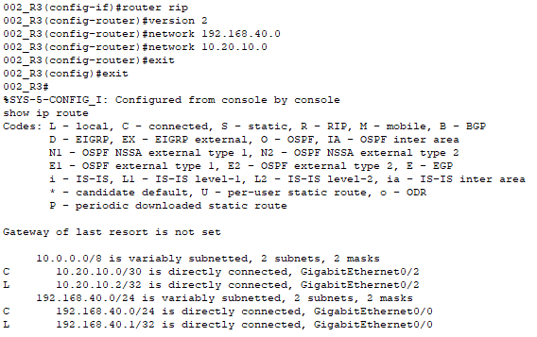

**Tes koneksi ICMP**

|  |  |  |  |  |
| --- | --- | --- | --- | --- |
| **NO** | **Sumber** | **Tujuan** | **Hasil** | |
| **Ya** | **Tidak** |
| **1** | **Pc 1** | **Pc2** | **Ya** | **-** |
| **Pc3** | **Ya** | **-** |
| **Pc4** | **Ya** | **-** |
| **Pc5** | **Ya** | **-** |
| **Pc6** | **Ya** | **-** |
| **Pc7** | **Ya** | **-** |
| **Pc8** | **Ya** | **-** |
| **Pc9** | **Ya** | **-** |

|  |  |  |  |  |
| --- | --- | --- | --- | --- |
| **NO** | **Sumber** | **Tujuan** | **Hasil** | |
| **Ya** | **Tidak** |
| **2** | **Pc 4** | **Pc1** | **Ya** | **-** |
| **Pc2** | **Ya** | **-** |
| **Pc3** | **Ya** | **-** |
| **Pc5** | **Ya** | **-** |
| **Pc6** | **Ya** | **-** |
| **Pc7** | **Ya** | **-** |
| **Pc8** | **Ya** | **-** |
| **Pc9** | **Ya** | **-** |

|  |  |  |  |  |
| --- | --- | --- | --- | --- |
| **NO** | **Sumber** | **Tujuan** | **Hasil** | |
| **Ya** | **Tidak** |
| **3** | **Pc 7** | **Pc1** | **Ya** | **-** |
| **Pc2** | **Ya** | **-** |
| **Pc3** | **Ya** | **-** |
| **Pc4** | **Ya** | **-** |
| **Pc5** | **Ya** | **-** |
| **Pc6** | **Ya** | **-** |
| **Pc8** | **Ya** | **-** |
| **Pc9** | **Ya** | **-** |

**Pc 1 -> pc5**

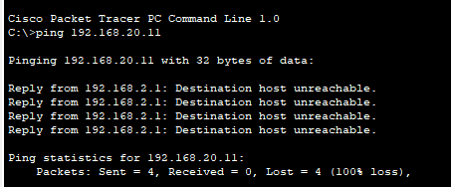

**Pc 1 -> pc 7**

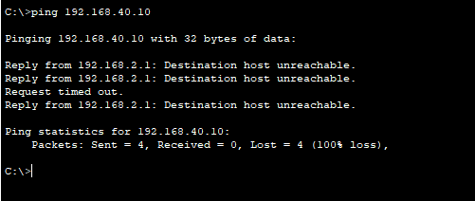

**Pc 4 -> pc 2**

**Pc 4 -> pc 8**

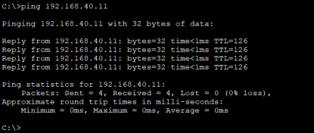

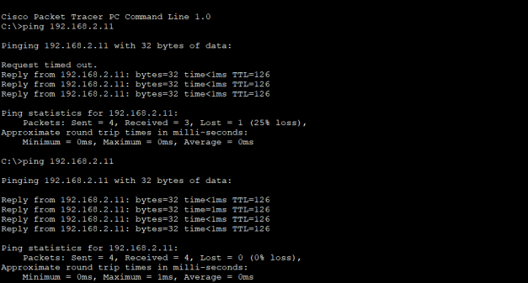

**Pc 7 -> pc 3**

**Pc 7 -> pc 9**

